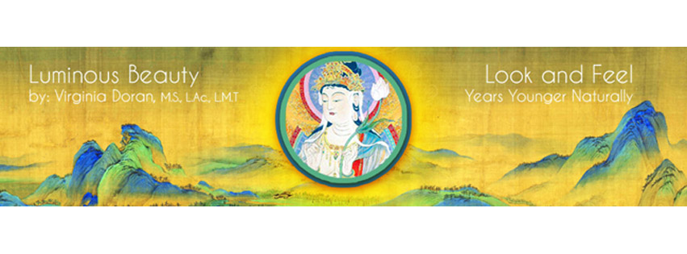FACIAL REJUVENATION with ACUPUNCTURE and MASSAGE/ ACUPRESSURE ACUPUNCTURE CERTIFICATION WORKSHOP Part 1 of the 3 part full Certification Program
LOCATION: Bridgeport, CT
June 26th-28th, 2015 - Friday 3:00 - 9:00pm, Saturday & Sunday 9:00 a.m. - 6:00 p.m.
CREDITS: 20 CEU's/PDA's for NCCAOM recertification available . Ms. Doran is an approved instructor by the American Acupuncture Council required for their malpractice coverage for cosmetic acupuncture.
PREREQUISITE: Open to acupuncture practitioners and students at a clinical level of training .
EARLY REGISTRATION: $535 for all 3 days with supplies if postmarked or paid by 6/1/15.
LATE REGISTRATION: $635 for all 3 days with supplies postmarked or paid after 6/1/15.
STUDENT REGISTRATION RATES: $435 3 days with supplies postmarked or paid by 6/1/15. After 6/1/15, late student reg. is $535.00. We can obtain malpractice insurance for students to participate for a small charge.
FOR MORE INFO: See the video trailer on www.luminousbeauty.com or Email (faster and preferred): inform@luminousbeauty.com or leave a voice mail message on 212-769-8278
TO REGISTER: By Paypal- email us OR make check to Luminous Beauty, LLC and send it with completed registration form and proof of malpractice insurance or student status to: Luminous Beauty, LLC., PO Box 537, Kent, CT 06757 (USA)
With this highly effective method of Facial Rejuvenation, one can simultaneously benefit a person's appearance and overall health. In this course, you will learn: ∗how to customize facial rejuvenation treatments based on Chinese and Japanese acupuncture ∗how to assess which meridians are involved in the various ways that individuals physically manifest the aging process ∗point selection and needle technique for conditions such as acne, dry skin, age spots, sagging skin, wrinkles, scars, double chins, as well as bags and dark circles under the eyes ∗ Acupressure, Qigong and Virginia’s own Integrated Deep Muscle Therapy (IDMT) techniques for preserving youthful appearance and combating signs of aging on the face.
∗Learn how to make your patients look and feel their best ∗BOOST your practice ∗ earn ceu’s/PDA’s * Learn from the originator! * Save your patients from unnecessary risks∗
NOTE: Please wear loose clothing as you will be expected to give and receive a full body acupuncture treatment on Sunday. Nails must be filed very short for the clinical component. Certification in Facial Rejuvenation Acupuncture from Ms. Doran is optional and may be granted to students who pass both a written and practical examination.
ABOUT THE INSTRUCTOR: As an experienced international teacher and practitioner of Facial Rejuvenation Acupuncture, Virginia Doran is a recognized expert in the field and had the great honor to be the first Westerner to teach acupuncture in Japan. Ms. Doran has been a teacher and lecturer in the field of holistic health since 1980 on the subjects of massage therapy, acupuncture, aromatherapy, flower essences, Chinese and Western herbs, nutrition and supplements. She graduated the Tri-State College for Traditional Chinese Acupuncture in 1995 as well as their postgraduate course in Chinese Herbology in 1999. Ms. Doran is nationally certified (NCCAOM) in acupuncture and Chinese Herbology. She graduated from the Swedish Institute of Massage and Allied Health Sciences in 1978 where she has since taught post- graduate courses and has been a licensed massage therapist practicing since 1979. Virginia has had the fortunate opportunity to have studied with Jeffrey Yuen and apprenticed with the late acupuncture master, Yuriko Yamagishi. Ms. Doran has been sought out by major television networks to demonstrate acupuncture facial rejuvenation. Ms. Doran has also been featured in and been a consultant to many magazines and newspapers on acupuncture for facial rejuvenation and dermatological conditions. To share with others the benefits of the publicity, Virginia created a referral service on her website for her students. She is currently writing two books on facial rejuvenation, one for practitioners and one for the public. Her instructional DVD series on FRA is now available on luminousbeauty.com along with video trailers, and articles.
UPCOMING WORKSHOPS: Part 1 -FRA 3 Day wkshp- Germany Sept. 2015, London and Austria in November 2015. Part 2- Aromatherapy for Facial Rejuv. Acc. To OM Principles- Litchfield County, CT August 7th-9th, 2015.

REGISTRATION FORM
Early registration is highly recommended as attendance is limited to allow for adequate clinical supervision.
________I will be attending the Facial Rejuvenation with Acupuncture and Massage June 26th-28th, 2015
Name as you would like it to appear on your certificate _________________________________________________
Work Phone_____________________________________Cell Phone_________________________________________
Home Phone___________________________ Other phone at time of workshop________________________________
Home Address__________________________________________________________________ #_________________
City________________________________ State/Province ________ Zip/Post Code____________ COUNTRY_______
Email______________________________________________________Fax____________________________________
Work address___________________________________________________________________ #__________________
City_______________________________ State/Province __________Zip/Post Code ________________COUNTRY________
Contact person and number in an emergency __________________________________________________________
How did you hear about this workshop? ____colleague ____mailing ____email ____Facebook ___Other (Pls..specify)
____I am a licensed acupuncturist in this/these state(s) ______ _____ I have malpractice insurance (Proof required)
____I am an acupuncture student at clinical level ____ I am a certified MD acupuncturist ____ND____Other (specify)
____I agree to not record the workshop or share the handouts or workshop content and techniques with others who aren’t attending
_____ I will receive and dress for a full body treatment ____I will sign a consent form for receiving treatment.
_____I will administer treatments in this workshop
Cancellation policy: If cancellation on or before June 3rd, 2015- full refund minus $25.00 processing fee. For cancellations between June 3rd, 2015 and June 15th, 2015 - a 50% refund will be issued. After June 15th, 2015, there is no refund. Written cancellations only by email.
_____ I have read the cancellation policy and agree to the terms.
_____ I will bring a patient / model for treating at 3:00 pm on June 26th, 2015 (Please let us know ASAP if you need someone to work on.)
_____ I have enclosed a check for the early registration rate of $535 (postmarked or paid before 6/1/15)
_____ I have enclosed a check for the early student reg. rate of $435 for (postmarked/paid before 6/1/15)
______I have enclosed a check for the late registration rate of $635 (postmarked/paid after 6/1/15)
______I have enclosed a check for the late student registration rate of $535 (postmarked/paid after 6/1/15)
Please make check payable to Luminous Beauty, LLC and send copy of your registration form, proof of licensure or certification in acupuncture, proof of student status, and a copy of your malpractice insurance policy to: Luminous Beauty, LLC, PO Box 537, Kent, CT 06757 USA OR EMAIL TO PAY BY PAYPAL.




