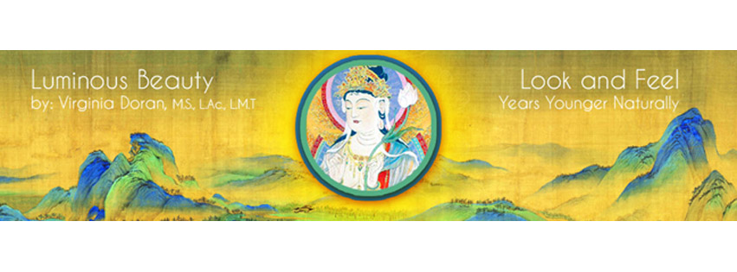AROMATHERAPY FOR FACIAL REJUVENATION according to
the Principles of Chinese Medicine Workshop - Part 2 of the 3 part full Certification Program

LOCATION: KENT, CT Gorgeous Litchfield County in Northwest Connecticut. Make it a deductible holiday! Some housing & free camping available onsite.
WHEN: August 7th-9th, 2015 - Friday 3:00 - 9:00pm, Saturday & Sunday 9:00 a.m. - 6:00 p.m.
CREDITS: 20 CEU's/PDA's for NCCAOM recertification available .
EARLY REGISTRATION: $535 for 3 days with supplies & 3 healthy meals if postmarked or paid by 7/1/15. LATE REGISTRATION: $635 for 3 days with supplies & 3 healthy meals postmarked or paid after 7/1/15.
STUDENT REGISTRATION RATES: $435 for 3 days with supplies & 3 healthy meals postmarked or paid by 7/1/15. After 7/1/15, late student reg. is $535.00 including supplies and 3 healthy meals.
FOR MORE INFO: See the video trailer on www.luminousbeauty.com or Email (faster and preferred): inform@luminousbeauty.com or leave a voice mail message on 212-769-8278 (slower response)
This fascinating in depth course will provide training in how to apply aromatherapy specifically for the purpose of facial rejuvenation. With over thirty five years of clinical experience using essential oils and knowledge of Oriental Medicine, Ms. Doran has created a highly effective and innovative approach for working with aromatherapy. She will teach the esthetic uses of individual essential oils from both a Western and Chinese medical perspective along with carrier oils, and hydrosols, an exciting new branch of aromatherapy that is extraordinarily useful in treating and caring for the skin. Some other dermatological applications will also be discussed. Highly effective formulas will also be revealed for specific conditions such as dry skin, combination skin, oily skin and acne, sensitive skin, puffiness, sagging skin, age spots, scars and wrinkles. Additionally, using essential oils on distal acupuncture points as a root treatment will also be introduced for some conditions and skin types. This root and branch style of aromatherapeutic treatment provides a more dramatic and lasting effect than either approach used separately. With this highly effective approach to Facial Rejuvenation, one can simultaneously benefit a person's appearance and overall health.

With extensive handouts, the course begins with general information on the subject that anyone practicing aromatherapy should know. This includes: the history of aromatherapy, how it works scientifically on the body and the psyche, the importance of natural versus synthetic products, how to identify and locate high quality products, ways to use aromatherapy, proper methods of handling and storage, ethical issues, cautions and contraindications, guidelines for making aromatherapy blends, and recommended books and sources for top quality oils, hydrosols, and ready-made aromatherapy products for facial rejuvenation. Detailed information for usage will be given for over fifty essential oils including the Chinese medical energetics, as well as twenty five carrier oils, and thirty hydrosols.

PLEASE NOTE: Some knowledge of Chinese medicine is suggested. No prior knowledge of aromatherapy is needed.

ABOUT THE INSTRUCTOR: As an experienced international teacher and practitioner of Facial Rejuvenation Acupuncture, Virginia Doran is a recognized expert in the field and had the great honor to be the first Westerner to teach acupuncture in Japan. Ms. Doran has been a teacher and lecturer in the field of holistic health since 1980 on the subjects of massage therapy, acupuncture, aromatherapy, flower essences, Chinese and Western herbs, nutrition and supplements. She graduated the Tri-State College for Traditional Chinese Acupuncture in 1995 as well as their postgraduate course in Chinese Herbology in 1999. Ms. Doran is nationally certified (NCCAOM) in acupuncture and Chinese Herbology. She graduated from the Swedish Institute of Massage and Allied Health Sciences in 1978 where she has since taught post- graduate courses and has been a licensed massage therapist practicing since 1979. Virginia has had the fortunate opportunity to have studied with Jeffrey Yuen and apprenticed with the late acupuncture master, Yuriko Yamagishi. Ms. Doran has been sought out by major television networks to demonstrate acupuncture facial rejuvenation. Ms. Doran has also been featured in and been a consultant to many magazines and newspapers on acupuncture for facial rejuvenation and dermatological conditions. To share with others the benefits of the publicity, Virginia created a referral service on her website for her students. She is currently writing two books on facial rejuvenation, one for practitioners and one for the public. Her instructional DVD series on FRA is now available on luminousbeauty.com along with video trailers, and articles.
UPCOMING WORKSHOPS: Part 1 –Facial Rejuvenation with Acupuncture and Acupressure/Massage 3 Day Certification Wkshp: Bridgeport, CT June 26th-28th, 2015, Germany Sept. 2015, London &Austria Nov. 2015.

REGISTRATION FORM
Early registration is highly recommended as attendance is limited to allow for adequate clinical supervision.
________I will be attending the Facial Rejuvenation with Aromatherapy workshop August 7th-9th, 2015
Name as you would like it to appear on your certificate _________________________________________________
Work Phone_____________________________________ Cell Phone_________________________________________
Home Phone___________________________ Other phone at time of workshop________________________________
Home Address__________________________________________________________________ #_________________
City________________________________ State/Province ________ Zip/Post Code____________ COUNTRY_______
Email______________________________________________________Fax____________________________________
Work address___________________________________________________________________ #__________________
City_______________________________ State/Province __________Zip/Post Code ________________COUNTRY________
Contact person and number in an emergency __________________________________________________________
How did you hear about this workshop? ____colleague ____mailing ____email ____Facebook ___Other (Pls..specify)
____I am a licensed acupuncturist in this/these state(s) ______
____I am an acupuncture student ____ I am an ND ____Other (specify)_________________________________
____I agree to not record the workshop or share the handouts or workshop content and techniques with others who aren’t attending
Cancellation policy: If cancellation on or before July 3rd, 2015- full refund minus $25.00 processing fee. For cancellations between July 3rd, 2015 and July 15th, 2015 - a 50% refund will be issued. After June 15th, 2015, there is no refund. Written cancellations only by email.
_____ I have read the cancellation policy and agree to the terms.
Registration rates include supplies and 3 healthy organic meals. Please inquire about housing onsite or in the area.
_____ I have enclosed a check for the early registration rate of $535 (postmarked or paid before 7/1/15)
_____ I have enclosed a check for the early student reg. rate of $435 for (postmarked/paid before 7/1/15)
______I have enclosed a check for the late registration rate of $635 (postmarked/paid after 7/1/15)
______I have enclosed a check for the late student registration rate of $535 (postmarked/paid after 7/1/15)
Please make check payable to Luminous Beauty, LLC and send copy of your registration form to: Luminous Beauty, LLC, PO Box 537, Kent, CT 06757 USA OR EMAIL TO PAY BY PAYPAL.




