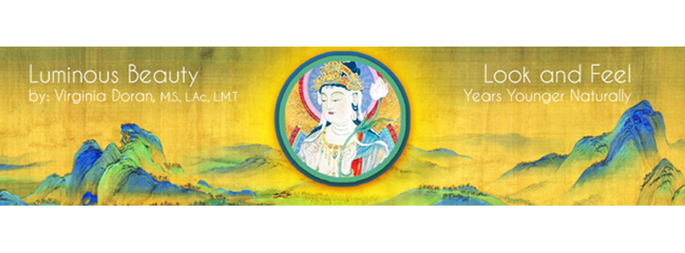FACIAL REJUVENATION with ACUPUNCTURE and MASSAGE/ ACUPRESSURE ACUPUNCTURE CERTIFICATION WORKSHOP- Part 1 of the 3 part full Certification Program
LOCATION: NEW YORK, NY (Greenwich Village)
March 18th- 20th, 2016 - Friday 4:00 - 9:30pm, Saturday & Sunday 9:00 a.m. - 6:00 p.m.
CREDITS: 20 CEU's/PDA's for NCCAOM recertification available . Ms. Doran is an approved instructor by the American Acupuncture Council required for their malpractice coverage for cosmetic acupuncture.
PREREQUISITE: Open to acupuncture practitioners and students at a clinical level of training .
EARLY REGISTRATION: $535 for all 3 days with supplies if postmarked or paid by 2/12/16.
LATE REGISTRATION: $635 for all 3 days with supplies postmarked or paid after 2/12/16.
STUDENT REGISTRATION RATES: $485 3 days postmarked or paid by 2/12/16. After 2/12/16, late student reg. is $585.00. These prices include supplies and additional malpractice insurance for students.
FOR MORE INFO: See the video trailer on www.luminousbeauty.com or Email (Email faster and preferred): inform@luminousbeauty.com or leave a voice mail message on 212-769-8278
TO REGISTER: By Paypal- email us your Paypal email address and we will send you an invoice for payment OR make check to Luminous Beauty, LLC and send it with completed registration form and proof of malpractice insurance or student status to: Luminous Beauty, LLC., PO Box 537, Kent, CT 06757 (USA)
With this highly effective method of Facial Rejuvenation, one can simultaneously benefit a person's appearance and overall health. In this course, you will learn: ∗how to customize facial rejuvenation treatments based on Chinese and Japanese acupuncture ∗how to assess which meridians are involved in the various ways that individuals physically manifest the aging process ∗point selection and needle technique for conditions such as acne, dry skin, age spots, sagging skin, wrinkles, scars, double chins, as well as bags and dark circles under the eyes ∗ Acupressure, Qigong and Virginia’s own Integrated Deep Muscle Therapy (IDMT) techniques for preserving youthful appearance and combating signs of aging on the face.
∗Learn how to make your patients look and feel their best ∗BOOST your practice ∗ earn ceu’s/PDA’s * Learn from the originator! * Save your patients from unnecessary risks∗
NOTE: Please wear loose clothing as you will be expected to give and receive a full body acupuncture treatment on Sunday. Nails must be filed very short for the clinical component. Certification in Facial Rejuvenation Acupuncture from Ms. Doran is optional and may be granted to attendees who pass both a written and practical examination.
ABOUT THE INSTRUCTOR: As an experienced international teacher and practitioner of Facial Rejuvenation Acupuncture, Virginia Doran is a recognized expert in the field and had the great honor to be the first Westerner to teach acupuncture in Japan. Ms. Doran has been a teacher and lecturer in the field of holistic health since 1980 on the subjects of massage therapy, acupuncture, aromatherapy, flower essences, Chinese and Western herbs, nutrition and supplements. She graduated the Tri-State College for Traditional Chinese Acupuncture in 1995 as well as their postgraduate course in Chinese Herbology in 1999. Ms. Doran is nationally certified (NCCAOM) in acupuncture and Chinese Herbology. She graduated from the Swedish Institute of Massage and Allied Health Sciences in 1978 where she has since taught post- graduate courses and has been a licensed massage therapist practicing since 1979. Virginia has had the fortunate opportunity to have studied with Jeffrey Yuen and apprenticed with the late acupuncture master, Yuriko Yamagishi. Ms. Doran has been sought out by major television networks to demonstrate acupuncture facial rejuvenation. Ms. Doran has also been featured in and been a consultant to many magazines and newspapers on acupuncture for facial rejuvenation and dermatological conditions. To share with others the benefits of the publicity, Virginia created a referral service on her website for her students. She is currently writing two books on facial rejuvenation, one for practitioners and one for the public. Her instructional DVD series on FRA is now available on luminousbeauty.com along with video trailers, and articles on FRA.
UPCOMING WORKSHOPS: Toronto- June 3rd-5th, 2016 * Seattle (Bastyr) June 17th-19th, 2016 & more Please inquire for workshops in your area.

REGISTRATION FORM
Early registration is highly recommended as attendance is limited to allow for adequate clinical supervision.
________I will be attending the Facial Rejuvenation with Acupuncture and Massage March 18th- 20th, 2016
Name as you would like it to appear on your certificate _________________________________________________
Work Phone____________________________________ Cell Phone_________________________________________
Home Phone___________________________ Other phone at time of workshop________________________________
Home Address__________________________________________________________________ #_________________
City________________________________ State/Province ________ Zip/Post Code____________ COUNTRY_______
Email______________________________________________________Fax____________________________________
Work address___________________________________________________________________ #__________________
City_______________________________ State/Province __________Zip/Post Code________________ COUNTRY________
Contact person and number in an emergency __________________________________________________________
How did you hear about this workshop? ____colleague ____mailing ____email ____Facebook ___Other (Pls..specify)
____I am a licensed acupuncturist in this/these state(s) ______ _____ I have malpractice insurance (Proof required)
____I am an acupuncture student at clinical level of training ______ I am a certified MD acupuncturist _____ND
____I agree to not record the workshop or share the handouts or content and techniques with those not in attendance.
____I will sign a consent form for receiving treatment (required) ____I will administer treatments in this workshop (required for certification). ____I will receive and dress for a full body treatment- let us know ASAP if you have contraindications and cannot have a treatment in class (not required to receive treatment).
Cancellation policy: If cancellation on or before Feb. 19th, 2016- full refund minus $25.00 processing fee. For cancellations between February 19th and 2016 and March 7th, 2015 - a 50% refund will be issued. After March 7th, 2015, there is no refund. Written cancellations only.
_____ I have read the cancellation policy and agree to the terms.
_____ I will bring a patient / model for treating at 3:00 pm on March 20th, 2016 (Tell us ASAP if you need someone.)
_____ I have enclosed a check for the early registration rate of $535 (postmarked or paid before 2/12/16
_____ I have enclosed a check for the early student reg. rate with insurance of $485 (postmarked/paid before 2/12/16)
______I have enclosed a check for the late registration rate of $635 (postmarked/paid after 2/12/16)
_____I have enclosed a check for the late student registration rate with insurance $585 (postmarked/pd after2/12/16)
Please make check payable to Luminous Beauty, LLC and send copy of your registration form, proof of licensure or certification in acupuncture, proof of student status, and a copy of your malpractice insurance policy to: Luminous Beauty, LLC, PO Box 537, Kent, CT 06757 USA OR EMAIL US TO PAY BY PAYPAL.
